
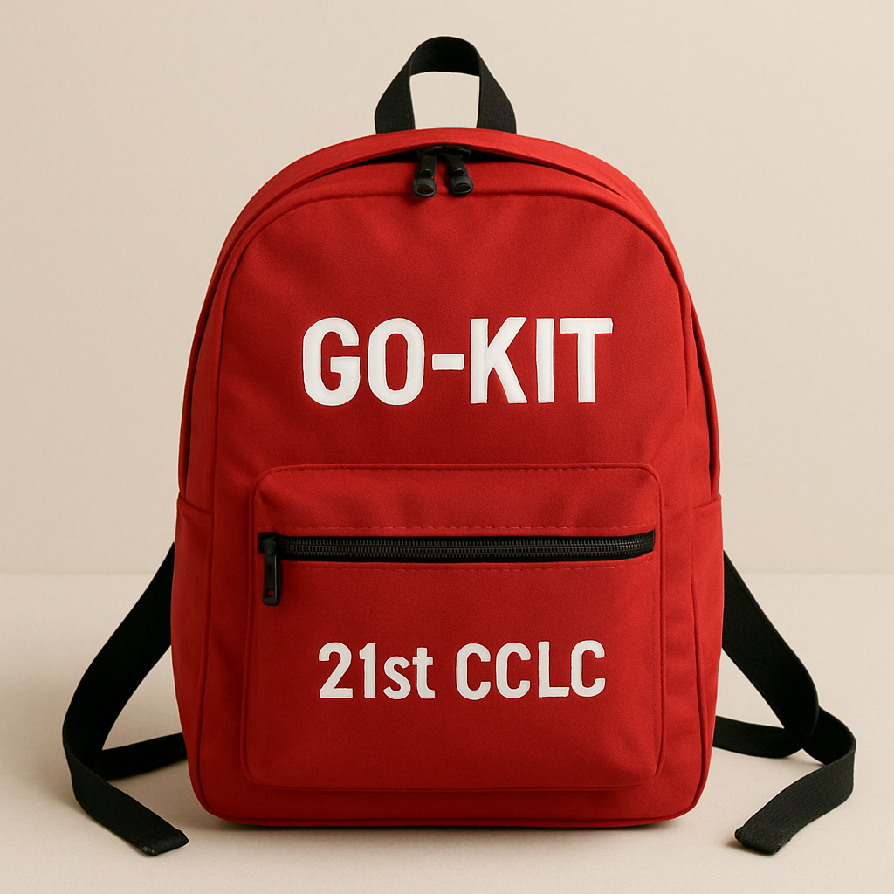

Pennsylvania Nita M. Lowey 21st Century Community Learning Centers

Front Pocket Contents:
- 1 – Ballpoint Pen
- 1 – Indelible Ink Pen – fine tip
- 1 – Lockdown Magnet for Door Jamb (instruction sticker on bag and reverse)

Main Pouch Contents:
- 1 – 44-piece First Aid kit
- 1 – Paper Towel roll
- 1 – CAT-style Tourniquet (with instructions)
- 1 – Trauma Pack
  - 1 – ½” x 2.5 yd. Waterproof Adhesive Tape
  - 6 – 4”x4” Gauze Pads
  - 1 – 2” x 4.1 yd. Elastic Gauze Roll
  - 1 – 3” x 4.1 yd. Elastic Gauze Roll
  - 4 – 5” x 9” ABD Combine Pad
  - 6 – Alcohol Prep Pads
  - 1 – Paramedic Shears
  - 2 – Nitrile Gloves – Large – Pair
- 1 LED Pump Flashlight
- 1 – 8-hour White Light Stick (bend, snap, shake)
- 1 – Clipboard (letter size) with 8 ½” x 11” paper pad
- 1 – Emergency blanket
- 1 – Poncho with hood
- 1 – Safety Mesh Vest (Orange)
- 1 – Metal whistle
- 25 – KN95 Masks
- 3 – Tissue packs
- 1 – Hand Sanitizer – 4 oz.
- 25 – Plastic bags – Large (uses on back)
- 1 – Duct tape – 2” x 10 yd.
- 6 – Water (multipack)

More Than a Trash Bag…
In emergencies and on field trips, plastic bags can be used for more than just garbage disposal.
Use your plastic bags as:
- Ponchos – cut a hole in the bottom for the neck and 2 holes on the sides for arms
- Ground Cover – to sit or lie on
- Emergency Toilet Facility – secure with duct tape
- Covers for Air Vents / Windows

Lockdown Magnet for Door Jamb
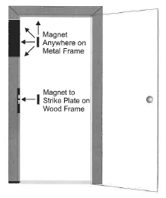
Metal Door Frame: Place the magnet anywhere on the door jamb.
Wooden Door Frame: Place the magnet over the strike plate.
- After the magnet is placed, re-lock the door.
- When the door is closed, it will not latch completely, allowing access to the room while keeping the door locked.
- In a lockdown situation, remove the magnet and close the door.

Remember:
- Keep the Go-kit visible and accessible.
- Keep the up-to-date student and staff emergency contact information in/with it.
- Keep the up-to-date Emergency Readiness Plan with it.
- Be familiar with and know how to use each item inside the Go-Kit.
- Review the Go-kit contents regularly for replenishment and expiration.
- Practice drills of all types regularly so that everyone is familiar with the process.

